# Phase 2: Org Setup & Configuration

## Salesforce Edition

* Edition Used: Developer Edition is used.
* Reason: Provides full customization capabilities (Objects, Flows, Triggers, Dashboards) free of cost and ideal for building this project.

## Company Profile Setup

* Update Company Name: ShopSmart Pvt. Ltd.
* Configure Default Time Zone: (GMT+5:30) IST (For India)
* Currency: INR (For India) or Multi-Currency for different countries.

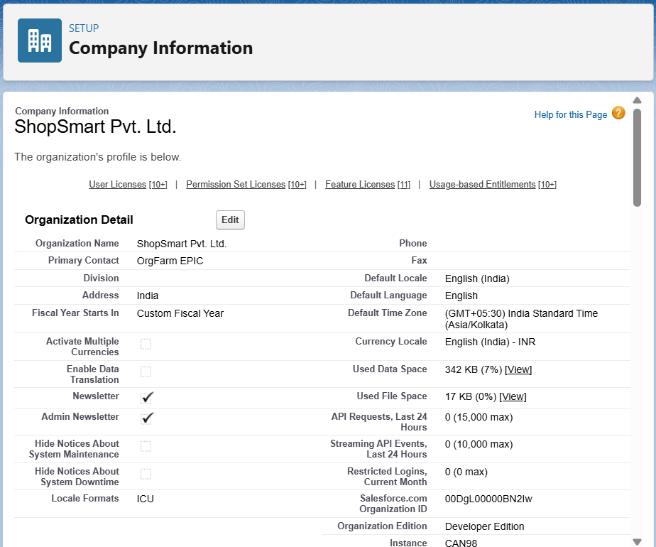

## Business Hours & Holidays

* Business Hours: Mon–Sat, 9:00 AM – 6:00 PM IST
* Holidays: Republic Day (26-Jan), Independence Day (15-Aug).
* Reason: Ensures any escalations, SLAs, and workflows follow working hours and avoid holidays.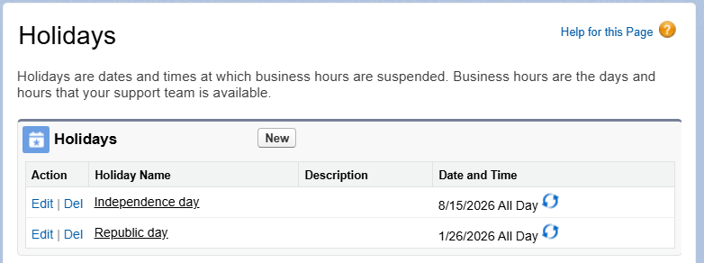

## Fiscal Year Settings

* Fiscal Year: Standard Calendar Year (Jan–Dec) is used unless custom accounting alignment is needed.
* Reason: Simplifies reporting alignment unless business requires April–March fiscal year.

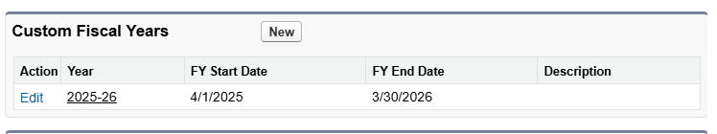

## User Setup & Licenses

This shows the user, role, responsibility, and assigned Salesforce license.

|  |  |  |
| --- | --- | --- |
| **User** | **Role** | **License** |
| **CEO** | **CEO** | **Salesforce** |
| **Sales Manager** | **Sales Manager** | **Salesforce** |
| **Warehouse Manager** | **Warehouse Manager** | **Salesforce** |
| **Customer Support** | **Support** | **Salesforce** |

## Profiles

Custom Profiles Created:

* CEO Profile: Full access to all objects.
* Sales Manager Profile: Full access to Leads, Opportunities, Orders; limited access to

Inventory.

* Warehouse Manager Profile: Read/Write on Inventory, Read/Write on Orders.
* Support Profile: Read-only on Orders, full access to Cases.

Reason: Profiles enforce object- and field-level security for different job roles.

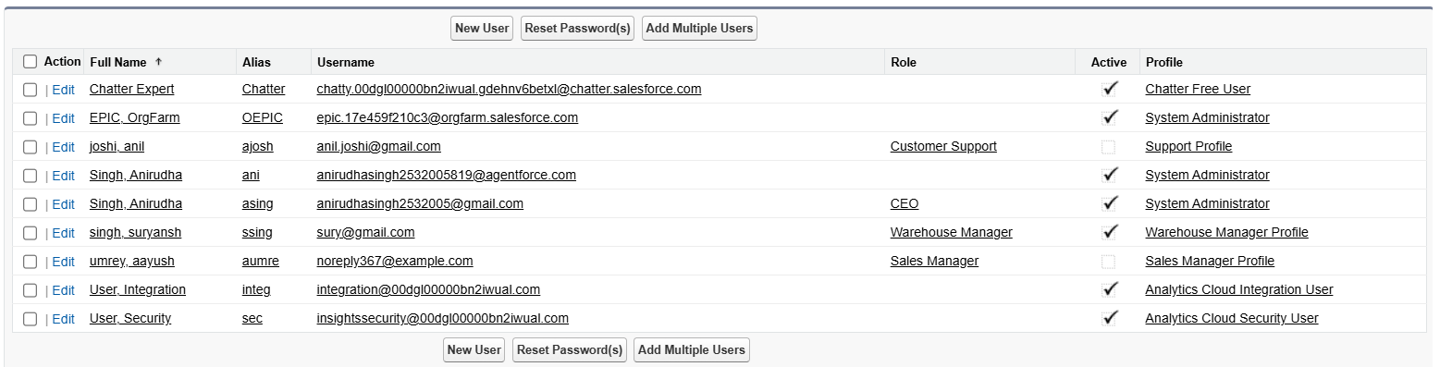

## Role Hierarchy

|  |  |  |  |
| --- | --- | --- | --- |
| **Role** | **Reports To** | **Responsibilities** | **Data Visibility** |
| **CEO** | **Top Level** | **Business owner, strategic decisions** | **Sees all records (Orders, Inventory, Products, Cases)** |
| **Sales Manager** | **CEO** | **Manages sales team, approves orders, monitors performance** | **Sees own + subordinates’ orders** |
| **Warehouse Manager** | **CEO** | **Manages inventory, updates stock, fulfills orders** | **Sees all orders (via sharing rule), edits inventory** |
| **Support** | **CEO** | **Handles customer queries, updates order status** | **Read-only access to Orders, full access to Cases** |

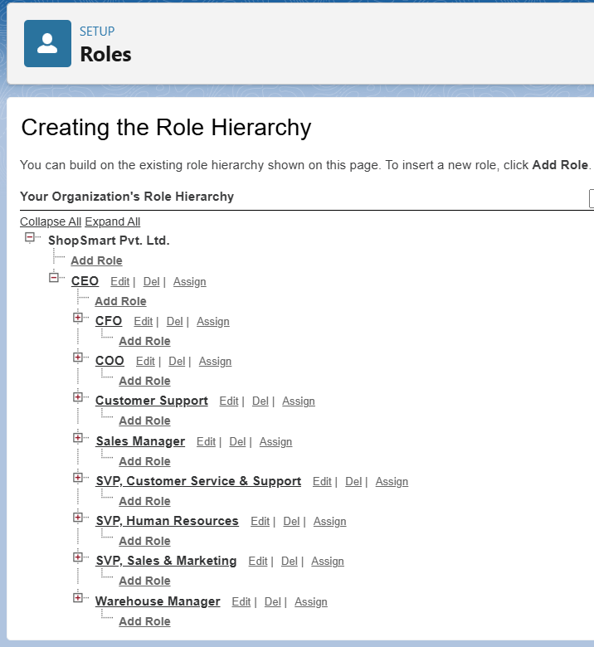

## Permission Sets

* Reports Access: Grants CEO and Sales Manager access to create and customize reports/dashboards.
* Inventory Access: Grants Warehouse Manager edit access to Inventory custom object.
* Order Management: Allows Support to update Order status fields.







## Organization-Wide Defaults (OWD)

* Accounts: Private
* Contacts: Controlled by Parent
* Orders: Private
* Cases: Private
* Products: Public Read Only
* Inventory: Private (shared with Warehouse Manager via Sharing Rule).

Reason: Ensures sensitive records are secure, shared only via hierarchy or rules.

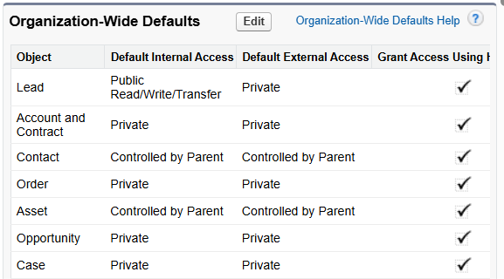



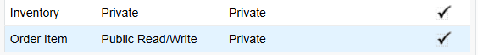

## Sharing Rules

* Orders with Status = 'Ready to Ship' → Shared with Warehouse Manager role (Read/Write).
* Customer Accounts (Type = Customer) → Shared with Support role (Read Only).

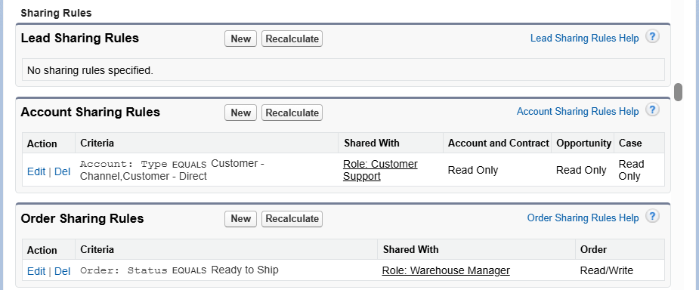

## Login & Security Policies

* Password Policy: Minimum length 8, lockout after 5 attempts.
* Session Timeout: 30 minutes.
* Enable Two-Factor Authentication (2FA) for CEO users.
* Restrict access using Login IP Ranges if required.

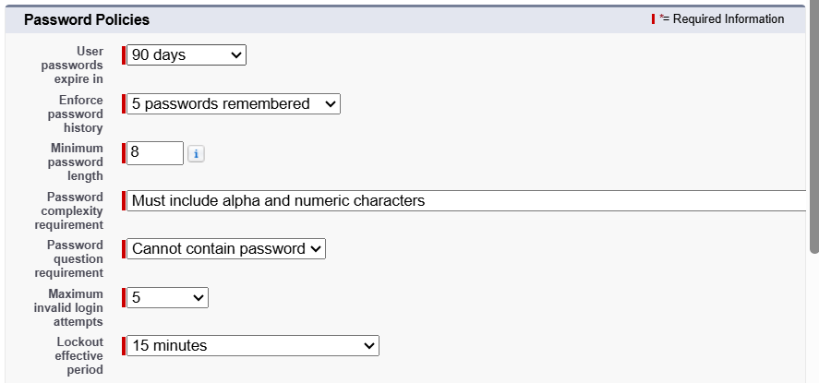



## Audit Trail & Field History

* Enabled Field History Tracking on Orders (Status, Total Amount) and Cases (Status).
* Enabled Setup Audit Trail for configuration changes.

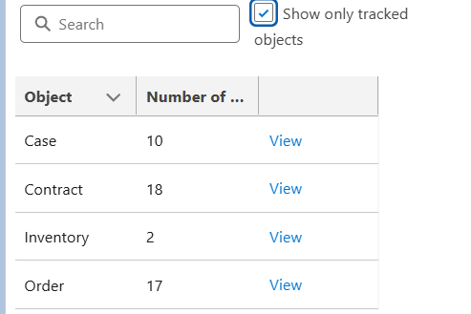

## Developer Org Setup & Deployment

Since Developer Edition is used, additional sandboxes are not available.  
For deployment strategy:  
- Use a second Developer Org for testing OR  
- Use Salesforce DX (SFDX) with scratch orgs.

Deployment options:  
Change Sets: UI-based, simple for small changes.  
Salesforce DX / CLI: Source-driven, recommended for version control and CI/CD pipelines.